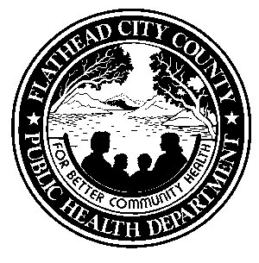
Community Health Services 751-8110 FAX 866-380-1740

Environmental Health Services 751-8130 FAX 751-8131

Family Planning Services 751-8150 FAX 751-8151

Home Health Services 751-6800 FAX 751-6807

WIC Services 751-8170 FAX 751-8171

Animal Shelter 752-1310 FAX 752-1546

Flathead City-County Health Department
1035 First Ave. West Kalispell, MT 59901
(406) 751-8101 FAX 751-8102
flatheadhealth.org

INSTRUCTIONS FOR CATCHING/EUTHANIZING A BAT

- DO NOT smash the bat’s head – the brain must be intact for the rabies test to be done.

- Wear heavy gloves and cover your skin with durable fabric pants and shirt or coat.

- Wait for bat to land; carefully place a clear plastic container (for which you have a tight-fitting lid) over the bat against a wall or floor. Slide a file folder or cardboard between the wall and the container to trap the bat. Once you have the bat in the container with the bottom of the container on a flat surface, place the lid to the container, then slide file folder/light cardboard and seal lid with tape. Bring it outside – where there is plenty of ventilation.

- Puncture a SMALL hole in the lid. Using engine starter fluid with ether, insert the included plastic tube applicator into the hole and put in 2 squirts (no more than 2 squirts). Then observe bat for 1-2 minutes, watching for any movement. If the bat is still moving, give one more squirt, and observe bat until it is motionless.

- Call the Flathead City-County Health Department (FCCHD)- Community Health at 751-8110 and make an appointment to bring in the bat. The bat must remain in the same clear plastic container and must be brought in as soon as possible. FCCHD will then submit the bat to the Montana Veterinary Diagnostic Lab for rabies testing.
  - Note: If it is after business hours, please refrigerate the bat until it can be brought to the Health Department, DO NOT put it in the freezer.

- As soon as the test result is received, FCCHD will contact you with the result.

- Note: FCCHD will not handle bats in situations where there is no human or animal exposure.
  - If rabies testing is still desired, a $31.50 fee for testing and a $25.00 fee for shipping will be charged.

- For more information on rabies go to our website at flatheadhealth.org and click on Health Alerts.

- If you need to contact the Health Department after 5 PM or on weekends for an emergency, call 751-8101 and you will be directed to our after-hours emergency call number.
August 2019

