Service | Fee | Cost
Spot Checking (1-4 pipes) | $200
Spot checking additional pipes  ($40/pipe) | $40
Total Cost
Receipt Number
Flathead City-County Health Department
1035 First Ave. West
Kalispell, MT 59901
(406) 751-8101 FAX 751-8102
www.flatheadhealth.org

GROUNDWATER MONITORING APPLICATION
Applicant Name__________________________________________ Phone _________________________ Applicant Address_________________________________________________________________________
Email: __________________________________________________________________________________
Parcel Address___________________________________________________________________________
Owner’s Name (if different) __________________________________________________________________
Legal Description Section______ Township______Range______Plat Room Tract ID ____________________
Legal Description _______1/4______1/4 Assessor #_____________________
Subdivision Name: _______________________________Lot _________ Block________________________
Directions or map showing how to access the site (no larger than 11 x 17).
Attach additional directions as necessary.
________________________________________________________________________________________
________________________________________________________________________________________
________________________________________________________________________________________
Instructions and Check List:
□ Complete the Groundwater Monitoring (GWM) application. The property owner’s signature is required for Groundwater Monitoring registration.

□ A site plan which shows the entire parcel, North arrow and detailed location of test pipes. All test pipes must be numbered and labeled. Test pipe labeling must coordinate with map and log.

□ Complete top portion and submit Groundwater Measurement Log. If the pipes are not registered, the monitoring is not accepted and may need to be completed the next monitoring season.

□ The application, site plan, GWM log and payment must be turned in to the Environmental Health Department for registration. Make check out to FCCHD.

□ Measurements must be recorded weekly on the department GWM Log (minimum of one recording every 7 days). Less frequent monitoring may void monitoring for the current period and result in the need to monitor through the next groundwater monitoring season.

□ Upon completion of monitoring, the owner/representative shall submit the completed GWM log. The application and log must be turned in to the department by August 1st of the current monitoring year.

GWM season begins March 15th – June 30th during the spring runoff season of every year. It will not be accepted after March 31st unless otherwise approved by the Department in writing.

Applicant Signature________________________________ Date_________________________________

By submitting this form, the property owner authorizes the Flathead City-County Health Department to enter onto their property for the purpose of observing groundwater levels at any monitoring pipe location. I hereby certify that submitted monitoring and logged measurements are true, complete and correct to the best of my knowledge.
Note: A parcel may not be re-monitored unless the new proposed pipe location is geographically or topographically unique from the previously monitored location. GWM pipe(s) may need to be re-monitored if the runoff is abnormally low, as determined by the Department. If a pipe(s) failed one year it may not be re-monitored another year. A new pipe can be installed in another location on the property at the discretion of the Department.
 | GROUNDWATER MONITORING MEASUREMENT LOG
Year ______________ |  |  | Zone ________________
 |  |  | Pre-Subdivision ________
Owner Name: _________________________________________________  Property Address: ___________________________ S____ T____ R____ Assessor Tract ID_______________________________________________ |  |  | Previously monitored  Yes___ No____  Septic Application ______

_______________________ _______________________
Date Registered Date Returned

Measurements must be in inches. If dry- note dry and record depth from A-B.
Initial | Date | Site # 1 |  |  | Site # 2 |  |  |  | Site # 3 |  |  | Site # 4
 | MM/DD/YY | A | B | A-B | A | B | A-B | A |  | B | A-B | A | B | A-B
Example | 3/15/2021 | 90” | 10” | 80” Dry

Installation Recommendations:
- A 10’ long 4” diameter schedule 40 perforated pipe is preferred. No perforations should exist in the first 3 feet of the pipe from the top down (2 feet above ground and 1 foot below ground). Perforations should be present in the last 7 feet of pipe below the ground surface to the bottom of pipe. This helps prevent surface water from entering the pipe at the ground level.
- Care should be taken when burying the pipe to not crush or bend it and to ensure that it remains vertical in the hole.
- Observation wells must be installed within 25’ of the proposed absorption system and on the same elevation.
- Mounding up material around the base of the pipe is acceptable and recommended to account for settling of the loose soils around the pipe after the hole is backfilled. Keep in mind that the “B” measurement must be taken from the natural ground surface. Environmental health staff will write this information on the pipe upon their first visit.
- Wrapping the pipe with a filter cloth or weed barrier can also help prevent soil from filling the pipe.

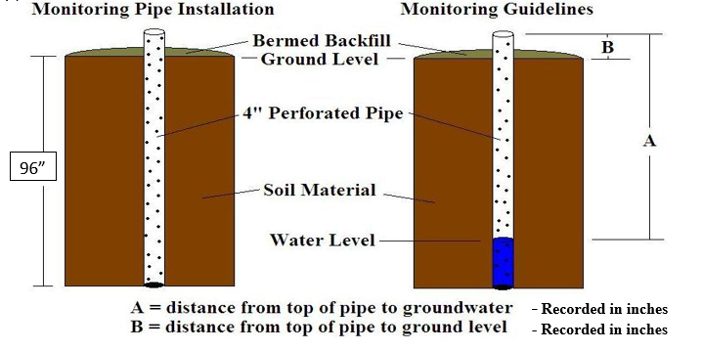
96”
24”
Measuring Procedures:
- Lower a measuring tape or stick to the water level and measure the distance from the water level to the top of the pipe (see example above). Water levels should be measured to the nearest inch. A plunking device or electronic water sensor can also be used. Data should be submitted in a similar form to that of the example on the Measurement Log.
- Measure the distance from the top of the pipe to the natural ground surface (B distance) (see example). Then measure the distance from the top of the pipe to the water level (A distance) (see example). Subtract B from A. This value equals the actual separation between the water table and the natural ground surface.

Note: Groundwater results alone do not dictate approval of a septic system.

